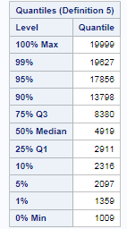**MONTHLY INCOME**

Since Monthly Income is a continuous variable, we created Income groups based on the quartiles. This ensures that each of the 4 group has 25% of the employees. The 4 groups are as: low income, medium income, high income, very high income. Using proc univariate, we obtained the result on the RHS and based on 25th, 50th, 75th percentiles we created the income groups as follows:

length income $20.;

if monthlyincome=**.** then income="null";else

if monthlyincome<=**2911** then income="low";else

if **2911**<monthlyincome<=**4919** then income="medium";else

if **4919**<monthlyincome<=**8380** then income="high";else

income="very high";

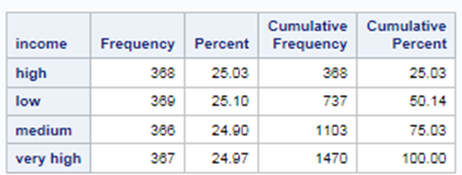Using Frequency procedure (proc freq) we obtain the frequency table as on the LHS. Here we see that each of the 4 groups has 25% of the employees.

* Low Income group: <=$2911
* Medium Income group: $2911 - $4919
* High Income group: $4919 - $8380
* Very High Income group: >$8380

**Survival Curve: Kaplan-Meier Method**

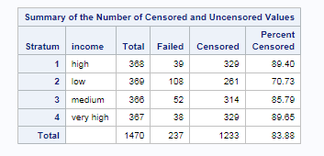The summary table on the LHS shows that attrition (as inferred from the “*failed”* column) is maximum in the **low income group** followed by **medium income group**. Attrition is comparatively very less in the **high** and **very high income groups**. The same can be inferred from the *“Percent censored”* column. We see its value is least for low income group and quite high for very high & high income groups. **Lower value of percent censored implies higher attrition.**

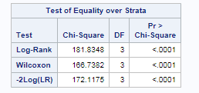The probability values of the Chi square statistics for all the three tests as shown on the RHS is significant i.e. <0.0001. Here the Null hypothesis is that survival curve is similar over strata and the Alternate Hypothesis is that it is NOT! Since the p-value is significant, we can reject the Null hypothesis and **safely conclude that the survival curve is different across the 4 income groups!**

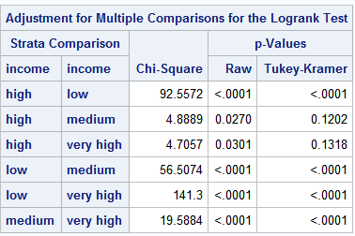The Log rank Adjustment table on the LHS shows Strata comparison. Here the significance of Tukey-Kramer p-value suggests that the survival curve between the two strata levels is different!

Survival Curves of

* High & Low income groups is different!
* High & Medium income groups is NOT different!
* High & Very high income groups is NOT different!
* Low & Medium income groups is different!
* Low & Very high income groups is different!
* Medium & Very high income groups is different!

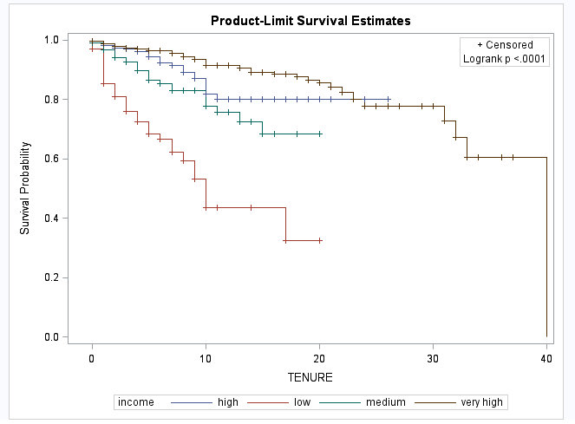The survival plot on the LHS shows that low income employees attrite at a faster rate as compared to the other groups since its curve is the steepest. **In 1 year, around 15% of the low income employees leave the company.** The high & very high income groups attrite at a much slower rate compared to the low & middle income groups. This inference is in line with our business logic since Low & Medium income employees are mostly entry level and they are continuously on a lookout for a more stable high paying job. On the other hand, the high & very high income employees attrite less since they are already in one!

**Survival Curve: Life Table Method**

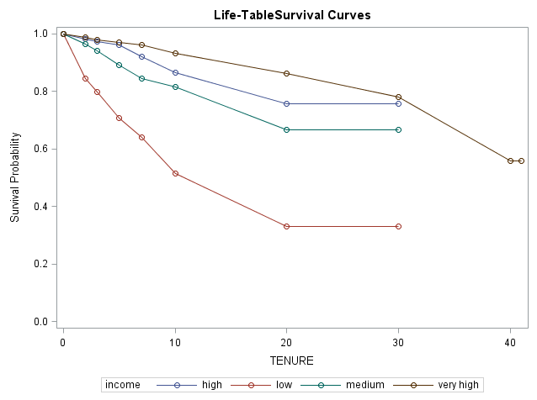

**Estimated Hazard Plot**

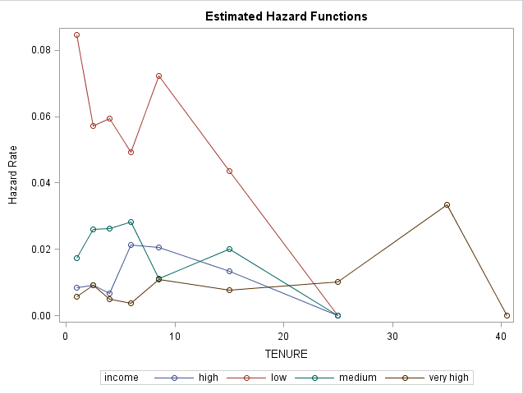The hazard of attrition for the low income group is the highest from the very first year. The hazard increases sharply for high income employees after year 6, thereafter declines gradually. For medium income employees the hazard increases sharply after year 2 and then declines sharply after year 8. Again picks up after year 10 and then starts to decline at year 15. For Very high income groups, the hazard remains more or less the same till year 15. **For the initial 15 years, low income & high income employees have the highest & lowers risks of attrition respectively!**

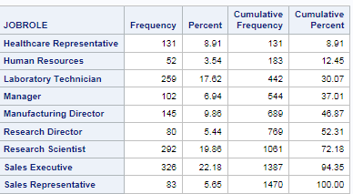**JOB ROLE**

The frequency table on the RHS shows that there are 9 job roles present in the company. **Sales Executive, Research Scientist, Laboratory Technician** are the 3 largest job roles accounting for around **60%** of the employees. With only 3.54% of the employees, Human Resources is the smallest group in the company.

**Survival Curve: Kaplan-Meier Method**

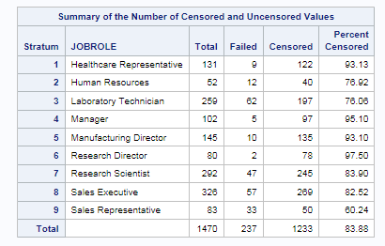The summary table on the LHS shows that **Sales Representatives, Laboratory Technicians and Human Resources attrite the most** as inferred from the “*Percent censored*” column. **Lower value of percent censored implies higher attrition.**

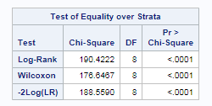The probability values of the Chi square statistics for all the three tests as shown on the RHS is significant i.e. <0.0001. Here the Null hypothesis is that survival curve is similar over strata and the Alternate Hypothesis is that it is NOT! Since the p-value is significant, we can reject the Null hypothesis and **safely conclude that the survival curve is different across the Job Roles!**

The Log rank Adjustment table on the LHS shows Strata comparison. Here the significance of Tukey-Kramer p-value suggests that the survival curve between the two strata levels is different!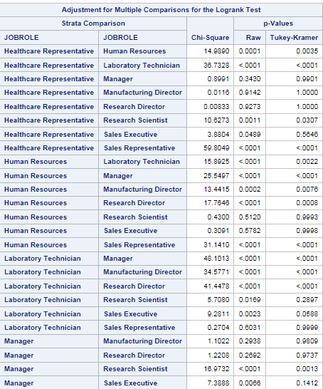 The survival curves of between the following Job Roles is different:

* Laboratory Technician & Healthcare Representative
* Laboratory Technician & Manager
* Laboratory Technician & Manufacturing Director
* Laboratory Technician & Research Director
* Sales Representative & Manager
* Sales Representative & Manufacturing Director
* Sales Representative & Research Director
* Sales Representative & Healthcare Representative
* Human Resources & Manager

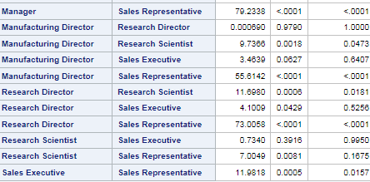

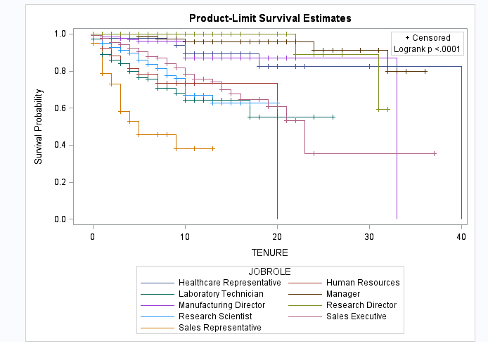The survival plot on the LHS shows that **Sales representative has the steepest curve followed by Laboratory Technician and Human Resources which implies that they attrite the most**. **In 1 year, 22% of the Sales representatives and 10% of the Laboratory Technicians leave the company.** On the other hand, Research Director, Manager have the most stable survival curves followed by Manufacturing Director & Healthcare representative. The steeper the survival curve is, the faster is the attrition over tenure. **The senior job roles of Research Director, Manager, Manufacturing Director have lesser attrition over time. It is interesting to see that though Healthcare representative is not a senior role, it has less attrition over time.** Obviously, employees having senior job roles don’t frequently switch companies as compared to their younger counterparts. They are normally well-settled in their job.

**Survival Curve: Life Table Method**

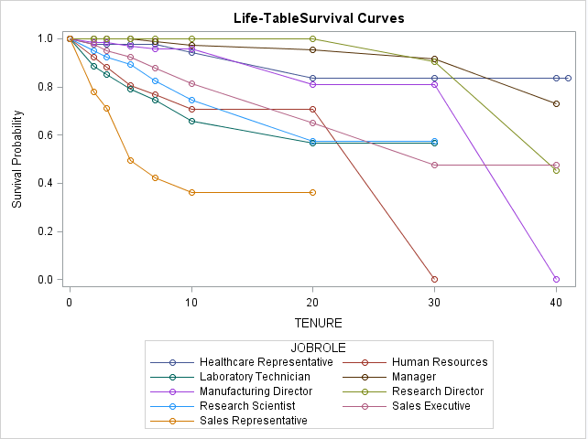

**Estimated Hazard Plot**

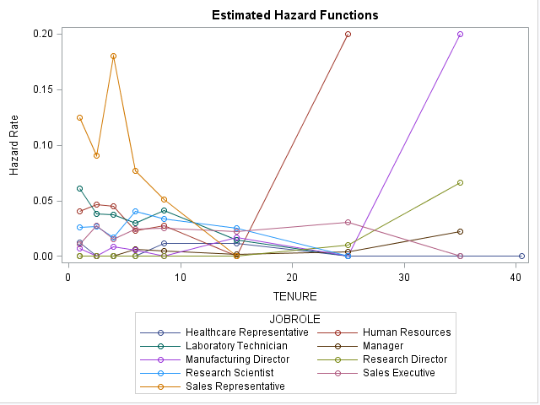The hazard for Sales Representative is the quite high from the very start. Attrition hazard for Human Resources & Manufacturing Director increases sharply after year 15 and 25 respectively. The hazard for Sales executive increases after year 2 and then declines after year 4. For Laboratory Technician, the hazard decreases sharply after year 2 and then gradually decreases till year 8 after which it again picks up. **For the initial 10 years, Sales representative has the highest risk of attrition while Research Director has a constant 0 risk of attrition!**

**JOB LEVEL**

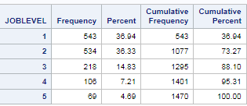Job Level shows the management level of the employee. From the frequency table on the LHS, we can say that 73.27% of the employees belong to low management levels with Job Level 1,2. In other words, they have junior positions in the company.

**Survival Curve: Kaplan-Meier Method**

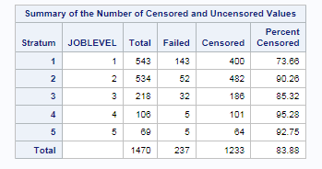The summary table on the RHS shows that employees with Job Level 1 attrite the most while employees with job Level 4,5 attrite the least as inferred from the “*Percent censored*” column. **Lower value of percent censored implies higher attrition.** In other words, **senior management attrite the least while junior employees attrite the most**. This has already been established in the previous analyses.

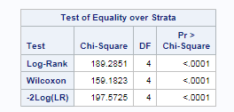The probability values of the Chi square statistics for all the three tests as shown on the RHS is significant i.e. <0.0001. Here the Null hypothesis is that survival curve is similar over strata and the Alternate Hypothesis is that it is NOT! Since the p-value is significant, we can reject the Null hypothesis and **safely conclude that the survival curve is different across the Job Levels!**

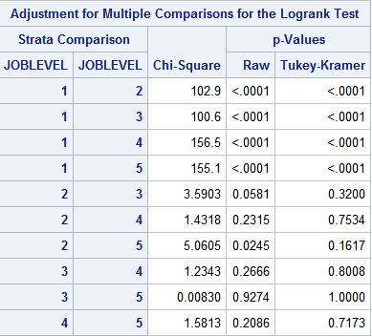The Log rank Adjustment table on the LHS shows Strata comparison. Here the significance of Tukey-Kramer p-value suggests that the survival curve between the two strata levels is different! The survival curves of between the following Job Roles is different:

* Job Level 1 &2
* Job Level 1 &3
* Job Level 1 &4
* Job Level 1 &5

This clearly shows that the survival curve of employees having junior positions is very different from the other management level groups.

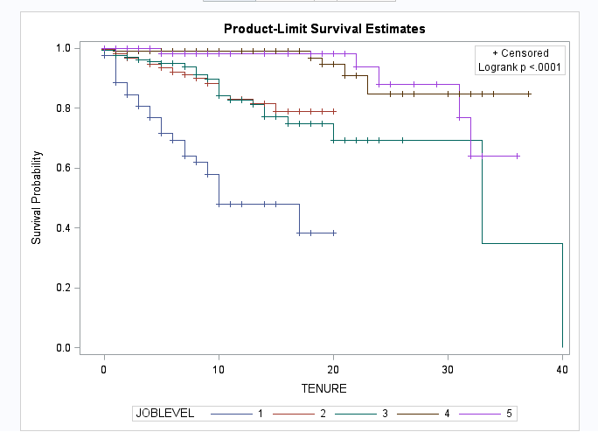The survival plot clearly shows that as the management level of the employee increases, the survival plot becomes less steep. The steeper the survival curve is, the faster is the attrition over tenure.

**We can conclude that employees having junior positions having job level=1 attrite the fastest over time and as the seniority of the employee increases, attrition lessens. In 1 year, 15% of the junior employees leave the company.**

**Survival Curve: Life Table Method**

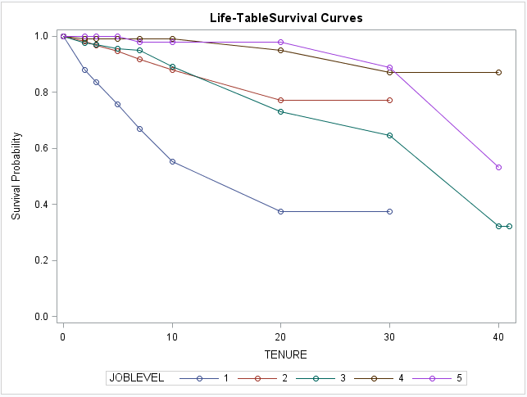

**Estimated Hazard Plot**

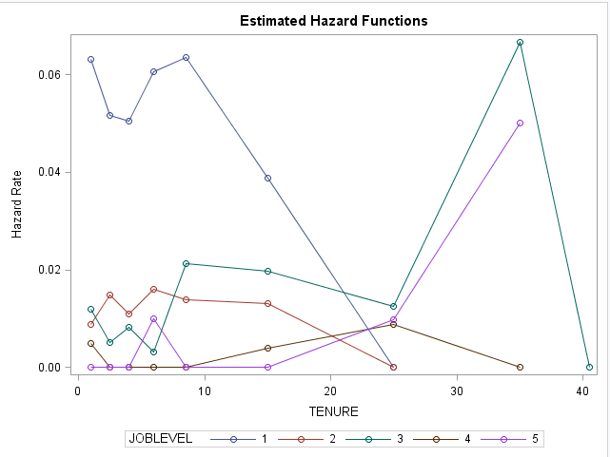The hazard for employees with JobLevel=1 is the highest from the very start till year 20. **Senior most management level employees have 0 risk of attrition for the initial 6 years !**

**JOB ROLE- “LABORATORY TECHNICIAN” & INCOME GROUP**

Since Laboratory technician is one of the largest job roles (17.62% of employees) in the company & their attrition is pretty high, we decided to look at the impact of income on their survival!

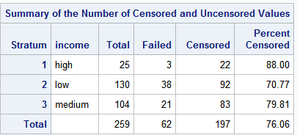 The summary table on the LHS shows that low income group among the Laboratory Technicians have the highest attrition as inferred from the “*Percent censored*” column. **Lower value of percent censored implies higher attrition.** Also around 50% of them belong to the low income group.

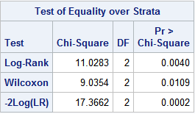The probability values of the Chi square statistics for all the three tests as shown on the RHS is significant <=0.05 at 5% level of significance. Here the Null hypothesis is that survival curve is similar over strata and the Alternate Hypothesis is that it is NOT! Since the p-value is significant, we can reject the Null hypothesis and **safely conclude that the survival curve is different across the income groups!**

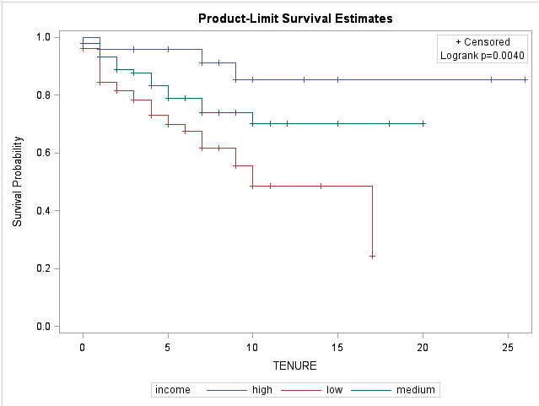The survival plot on the RHS shows that Low Income Laboratory Technicians attrite at a faster rate over time than the medium and high income ones. **In 1 year, 10% of the low income Laboratoty Technicians leave the company.**

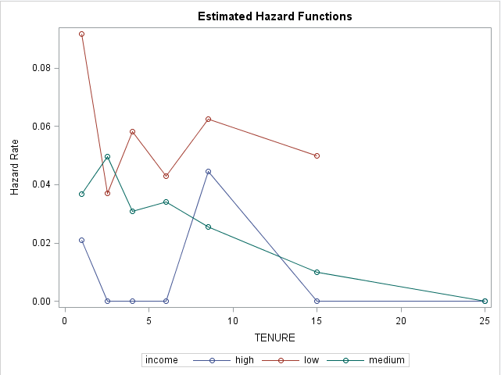The hazard for Low income LTs decreases sharply after year 1. For medium income LTs, the hazard increases after year 1 and after year 2 it decreases and thereafter decreases gradually. For high income LTs the hazard decreases after year 1 and thereafter remains constant till year 5 and then increases sharply till year 10 and then decreases sharply till year 15.

**JOB ROLE- “RESEARCH SCIENTIST” & INCOME GROUP**

Since Research Scientist is one of the largest job roles (19.86% of employees) in the company, we decided to look at the impact of income on their survival!

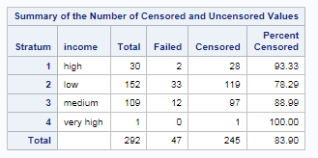The summary table on the LHS shows that low income group among the Research Scientists have the highest attrition as inferred from the “*Percent censored*” column. **Lower value of percent censored implies higher attrition.** Also **around 86% of them belong to the low& medium income groups**.

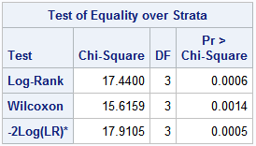

The probability values of the Chi square statistics for all the three tests as shown on the RHS is significant <=0.05 at 5% level of significance. Here the Null hypothesis is that survival curve is similar over strata and the Alternate Hypothesis is that it is NOT! Since the p-value is significant, we can reject the Null hypothesis and **safely conclude that the survival curve is different across the income groups!**

The survival plot on the LHS shows that Low Income Research Scientists attrite at a faster rate over time than the medium and high income ones**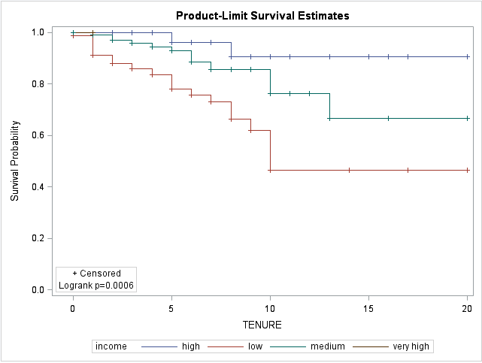. In 1 year, 10% of the low income Research Scientists leave the company.**

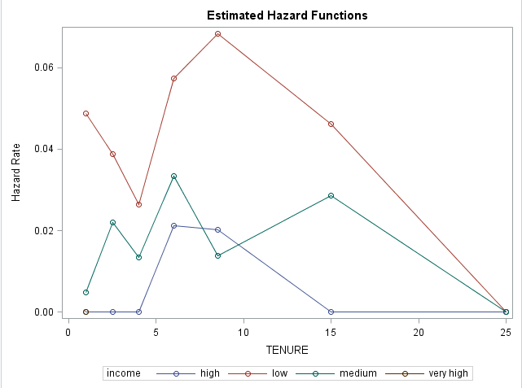The hazard for low income Research Scientists decrease till year 5 and then picks up till year 10 after which it starts to decline again. The attrition risk for high income RSs is 0 constant till year 5 after which it increases and thereafter declines. **Low income RS’s have the highest hazard and high income RS’s have 0 hazard for the initial 5 years!**

**JOB ROLE- “SALES EXECUTIVE” & INCOME GROUP**

Since Sales Executive is the largest job role (22.18% of employees) in the company, we decided to look at the impact of income on their survival!

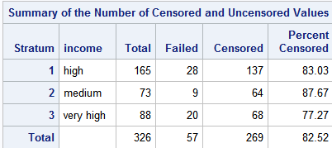The summary table on the LHS shows that very high income group among the Sales executives have the highest attrition as inferred from the “*Percent censored*” column. **Lower value of percent censored implies higher attrition.**

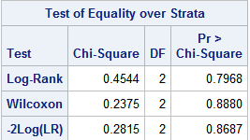

The probability values of the Chi square statistics for all the three tests as shown on the RHS is insignificant >=0.05 at 5% level of significance. Here the Null hypothesis is that survival curve is similar over strata and the Alternate Hypothesis is that it is NOT! Since the p-value is significant, we can reject the Null hypothesis and **safely conclude that the survival curve is NOT different across the income groups!**

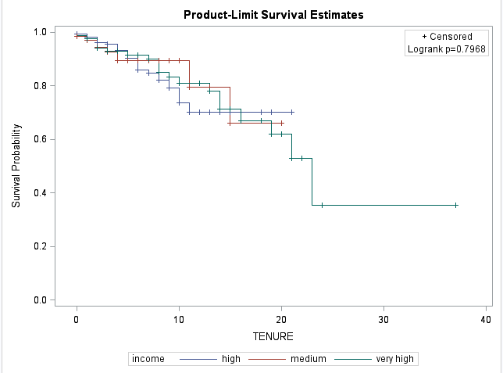The survival plot also shows that attrition pattern is not significantly different among the income groups!

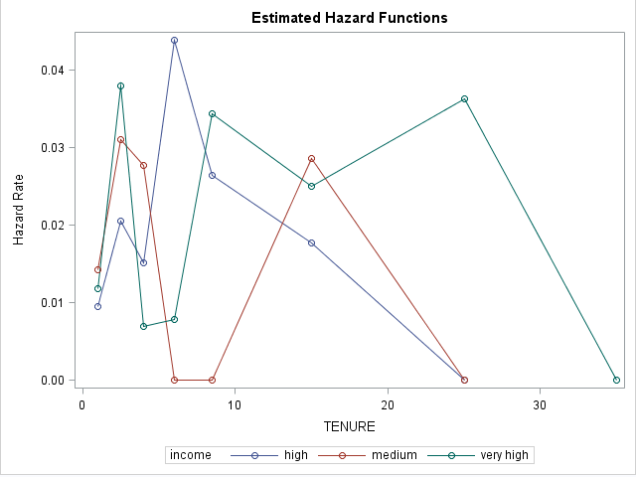Hazard rate is highest for very high income group at year 4 and decreases sharply thereafter. Again increases sharply after year 8. **High income SEs & Very high income SEs have the lowest & highest hazard rate respectively for the initial 4 years.**